“Drone Delivery Route Problem with Uniform Cost Search Algorithm”

-What is Uniform Cost Search: -
.Uniform Cost Search is an uninformed search algorithm that expands the node with the lowest total path cost from the start node to the goal. The algorithm guarantees finding the optimal solution when all costs are non-negative.

-Why UCS in Drone Delivery Problem: -
.Uniform Cost Search is suitable for the Drone Driven Route problem because the costs between routes are not equal. UCS ensures that the drone always chooses the path with the lowest total cost, which is critical for minimizing battery usage or travel time.

-How UCS Work: -

Initialization: The algorithm starts by adding the start node to the priority queue with a cumulative cost of 0.
Expansion: In each iteration, it removes the node with the lowest cost from the priority queue.
Goal Check: If the removed node is the goal node, the algorithm terminates and returns the path.
Neighbor Exploration: Otherwise, it expands the node and explores all its unvisited neighbors. It calculates the new cumulative cost for each neighbor by adding the current node's cost to the edge cost.
Queue Update: Neighbors are added to the priority queue. If a neighbor is already in the queue but a cheaper path to it is discovered, the algorithm updates its cost in the queue (a "decrease key" operation).
Repetition: Steps 2-5 are repeated until the goal is found, or the queue is empty.

-Python Implementation: -

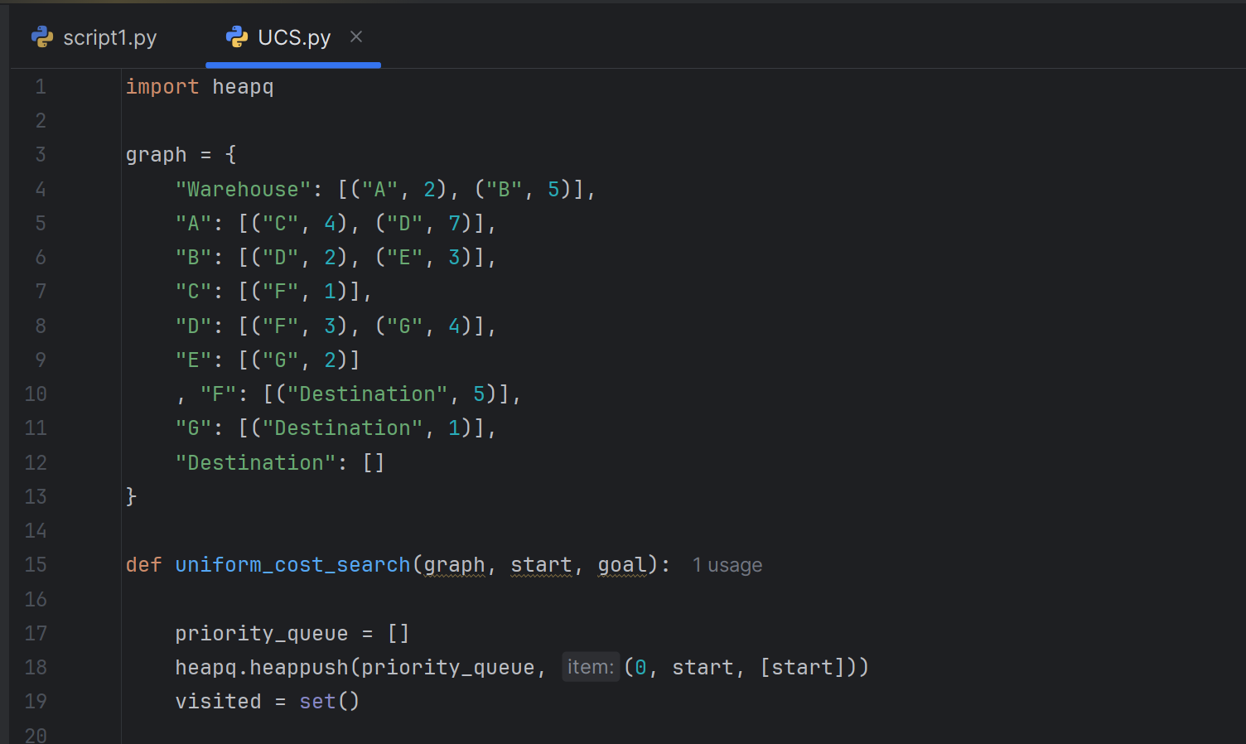

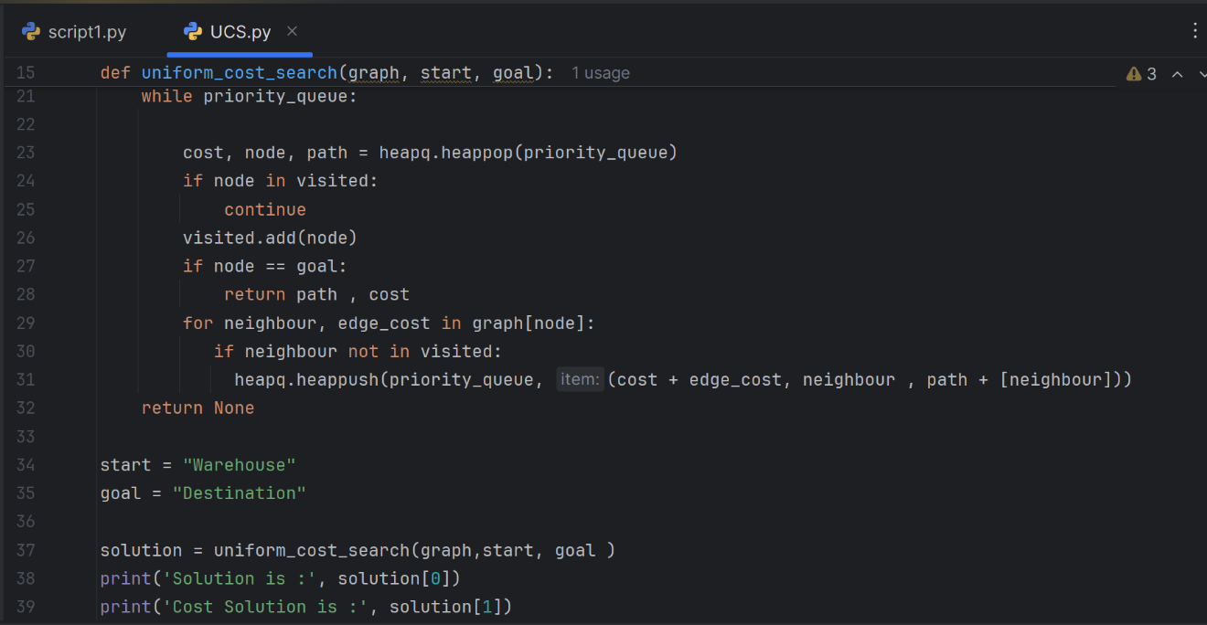

-Code Output: -

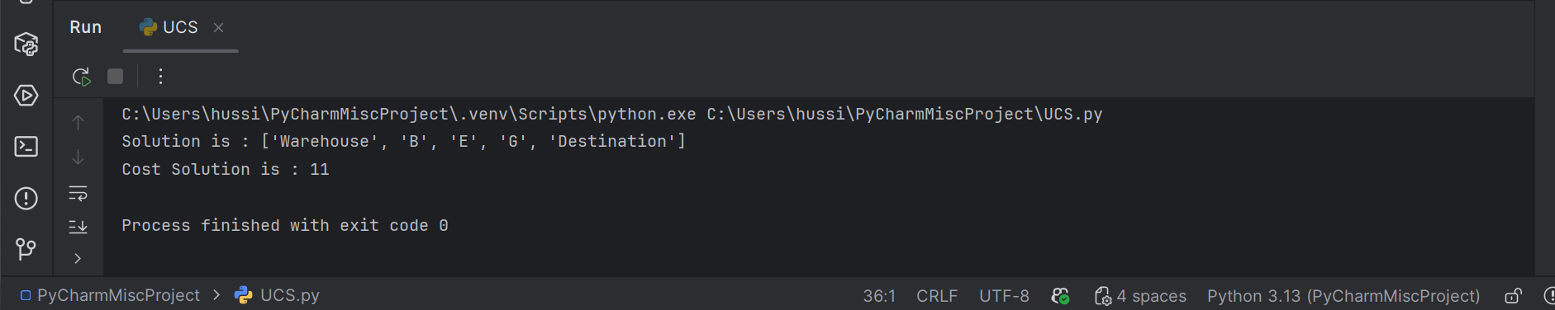

-Advantages: -
1- Guarantees the optimal solution.
2- Works well when path costs vary.
3- Simple and reliable for cost-based path-finding problems.

-Disadvantages: -
1- Can be slow for large graphs.
2- Requires high memory usage.
3- Less efficient compared to heuristic-based algorithms such as A*.

-Comparation Measures For UCS: -
.Execution Time:
- Time Complexity: O(E log V)
Where:
- V is the number of vertices (locations)
- E is the number of edges (routes)
In the Drone Driven Route problem, the execution time increases as the number of possible routes increases, making UCS suitable for small to medium-sized environments.

.Memory Usage:
Uniform Cost Search stores all generated nodes and paths in memory until the goal is reached.
- Space Complexity: O(V)
For the drone routing problem, memory usage can become significant if the environment is large or highly connected.

.Success Rate:
Uniform Cost Search has a high success rate.
- It always finds a solution if one exists.
In the Drone Driven Route problem, UCS reliably finds a valid delivery route whenever one exists.

.Completeness:
Uniform Cost Search is a complete algorithm.
- It is guaranteed to find a solution if one exists
- This holds as long as all path costs are non-negative

.Optimality:
Uniform Cost Search is optimal.
- It always returns the path with the minimum total cost.
- This is one of the main reasons it is used in cost-sensitive problems.
For the Drone Driven Route problem, this ensures minimal battery consumption, travel time, or distance.

.Scalability:
Uniform Cost Search has limited scalability.
- Performance degrades as the size of the graph increases.
- It explores many nodes without using heuristics.
For large-scale drone delivery systems, heuristic-based algorithms such as A* are more efficient and scalable.

